**General FAQs**

**Compensation**

**Q: Is there a way to get a list of the ways compensation flows for each of the offers? Is it the same? or is it different for each offer?**

A: Per Bob, we only have compensation flows for AppD and TE at this time. Others are currently being worked on.

**Reporting**

Q. Can I Run a Usage Report in Subscription Workbench to view my prior months usage?

**A. Yes. Follow the instructions below in Subscription workbench.**

You will need to click Export button to extract the data to Excel

**Ordering**

Q: Why is a distributor unable to place a $0 USD subscription order for a new partner (CCW is not recognizing their MSLA designation)?  
  
A: If the partner recently signed the PPE – it will then be 24-48 hours for it to be valid through CCW.

**Specific MSLA Offer FAQs**

**Umbrella**

Q. How do I sign up for Black Belt Fire Jumper Umbrella MSSP Console Onboarding Training?

A. [Fire jumper Training course](https://salesconnect.cisco.com/sc/s/learning-trac-detail-standard?ltui__urlRecordId=a1Y8c00000EM3HKEA1) explains Cisco Umbrella for MSSP and how to use the Managed Services Console, plus licensing, configuration, administration, tuning and troubleshooting. Click on the link to Register.

Q. What are all the Cisco trainings available to me as a Partner/Distributor?

A. [Cisco Black Belt Academy](https://salesconnect.cisco.com/blackbeltpartneracademy/s/) provides a simplified & uniformed role-based education framework across all Cisco architectures and solutions. Black Belt Academy helps Cisco Partners and Distribution in selling, deploying and supporting the latest technology and software solutions with enablement on tools and programs required for backend operations to better assist our joint customers.

Q. How does a Partner gain access to the MSSP Console? Can I add MSLA licensing as an option in the MSSP console? **Yes**, you will need access to the MSSP Console in order-to-order MSLA license.

A.  **The Partner will need to take the following** [**steps to gain access the MSSP Console for the first time**](https://learn-cloudsecurity.cisco.com/umbrella-resources/umbrella/cisco-umbrella-for-mssps-requirements)

1. Step 1 – Two SEs per partner GEO ID will need to complete the Umbrella course material and quiz for Fire Jumper (on Sales Connect)
2. Step 2 – After training is completed, Partner will need to enroll in the [Cisco Program Management and Application Tool (PMA)](https://ibpm.cisco.com/cpp/apps/login/app/CPPE_/Ya3-piA1UkDVj5-n5nB4wA*/!STANDARD?_gl=1*s4oupz*_gcl_au*Mzc0NTI5OTQ4LjE3MDkwNjc5ODc.&_ga=2.79979987.590916234.1709230101-399584684.1709067987)
3. Step 3 – Send the saved screenshot(s) from your Fire Jumper training to <umb-mssp-provision@cisco.com> and request access to the MSSP console. You will receive an email confirmation after submission. Cisco will evaluate your application and respond shortly thereafter.

**Partner can add MSLA licensing as an option in the MSSP Console by taking the following steps:**

1. Partner must add MSLA licensing as an option in MSSP console. Please review the Partner Program Enrollment (PPE) section (1.7 PPE Enrollment in the [MSAL Ordering Guide](https://www.cisco.com/c/dam/en/us/products/se/2018/7/Collateral/msla-og.pdf) for instructions (email [umbrella-orders@cisco.com](mailto:umbrella-orders@cisco.com) for support)
2. Review the Umbrella MSSP section (1.11.6 Umbrella MSSP) in the MSLA Ordering Guide and follow those instructions to place an order or a change subscription order. **This additional step of placing a zero-dollar order in The Commerce Workspace (CCW) is required (you cannot do this unless you have taken the steps above).**

*If you are an Existing SP’s looking to add new packages you must perform a Change Subscription for Umbrella for MSSPs*

Q. Can I merge to another Partner?

A. Partners cannot move their end customers between partners themselves, but support can assist with customer migrations*. (*[*Umbrella-support@cisco.com*](Umbrella-support@cisco.com)*)*

Partners don’t have the provision to move their end customers between the partners. (Only MSLA customers, not term customers can move to another Partner). Can not migrate mid-term. Support will provide the provisioning to move the partners.

Q. Can a Partner migrate one of their client's ORG into a standalone UMB-EDU-SUB dashboard? This is asked by the end customer as they are opening a tender for renewing their service.

A. Yes, this is possible and requires a few manual steps.

1. A new order must be placed for the org they would like to separate because standalone orgs only support term licensing.
2. As default process, they will get the new umbrella org created. Cloud Security Sales Operations ([umbrella-orders@cisco.com](mailto:umbrella-orders@cisco.com)) Team can detach the current org and swap the order/subscription with already existing org.

Q: Can a customer/partner change the distributor they are currently working with if there is an existing or active subscription ID?

A: Partners can cancel uncommitted subscriptions in Subscription Workbench. The partner needs to cancel their current subscription before they can move to an engagement with the new distributor. Any pending orders (SubID) with a new distributor will not be released until the customer/partner (or their current distributor) cancel the previous subscription. The Cisco Umbrella team will only move the customer's org ID in console once the previous engagement is closed.  
Note that, for committed subscriptions, they will need special approval from the Business Unit Norman Chang (norchang@cisco.com).

Q: We have a request for ThousandEyes via MSLA

Since ThousandEyes MSLA is still in LA it is not exposed to everyone yet (same as AppD MSLA).

In terms of the TE Requirements Greg Meuse hand holds every partner that is interested in it before signing them up.

There are two 2 main requirements:

* They have completed ThousandEyes Blackbelt training (<https://cs.co/learn-te>)
* They can show a decent TE MSLA pipeline.
* Please also see attached overview of TE for MSP Requirements

He also checks to see what existing TE business they have had so far in general.

 Once they are vetted, they need to do a POV and trial licenses are provided to them.

  Here’s the link where some of this is documented [ThousandEyes as a Managed Service (cisco.com)](https://salesconnect.cisco.com/thousandeyes/s/partners/msp" \o "https://salesconnect.cisco.com/thousandeyes/s/partners/msp)

Q. What steps do I need to take, as a Partner, to sign MSLA PPE Agreement?

The user needs to have access to Program Management & Application. Once they are in the partner portal, they can go to the Program Enrolment tab. And they should see the Eligible programs there. If this is blank it means that the user that is logging in does not have access to PMA and PPE.

[MSLA_PPE_Instructions.pdf (cisco.com)](https://salesconnect.cisco.com/softwarebuyingprograms/apex/scormanywhere__SCORM_Player?courseId=a1m8c00000plDmSAAU)

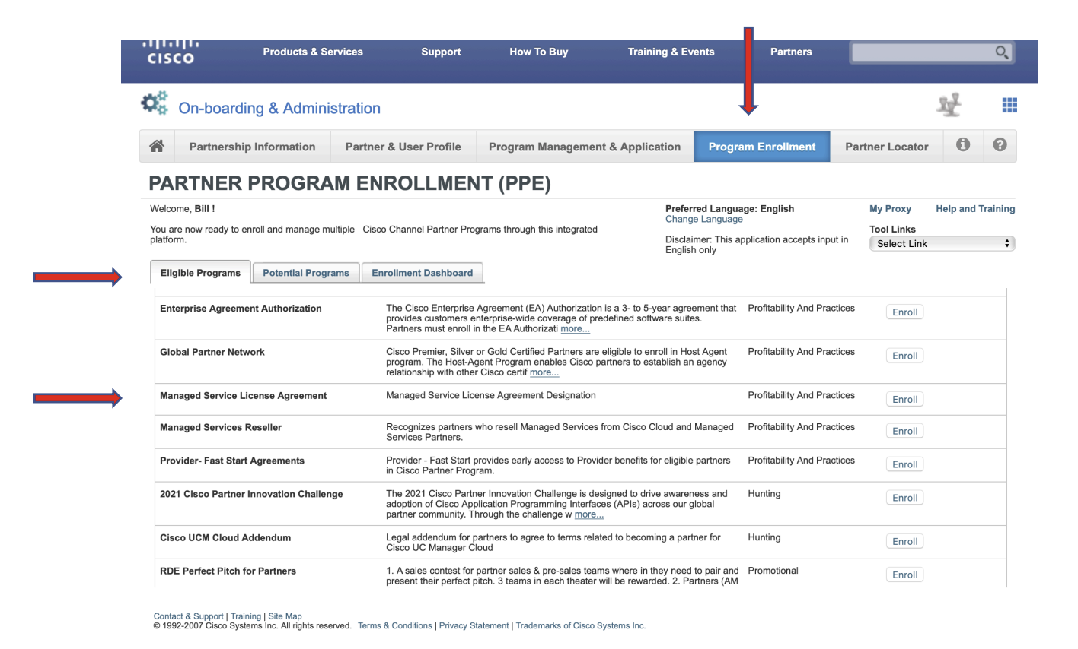

**Q. What will happened if I turn off “Auto-Renew” for my subscriptions and need to renew?**

A. If you turn off Auto-renew your subscription will NOT renew and your subscription will expire. You will be unable to consume and will show no usage or receive any further monthly billing. In the event your subscription does expire, and you wish to turn it back on, below are the steps you will need to take:

1. Partner will need to Enroll in the Partner Program and re-sign the MSLA PPE Agreement [MSLA_PPE_Instructions.pdf (cisco.com)](https://salesconnect.cisco.com/softwarebuyingprograms/apex/scormanywhere__SCORM_Player?courseId=a1m8c00000plDmSAAU)
2. Submit a new quote to re-order your subscriptions
3. Once the order is approved you will receive a new SubID and can start consuming again